1. Explain the working of SQOOP in brief.

* Sqoop is a tool designed to transfer data between Hadoop and relational database servers.
* It is used to import data from relational databases such as MySQL, Oracle to Hadoop HDFS, and export from Hadoop file system to relational databases.
* **Sqoop Import**

The import tool imports individual tables from RDBMS to HDFS. Each row in a table is treated as a record in HDFS. All records are stored as text data in text files or as binary data in Avro and Sequence files.

* **Sqoop Export**

The export tool exports a set of files from HDFS back to an RDBMS. The files given as input to Sqoop contain records, which are called as rows in table. Those are read and parsed into a set of records and delimited with user-specified delimiter.

1. Import a table from Mysql to HBase table using Sqoop.

//CREATING A DB IN MYSQL

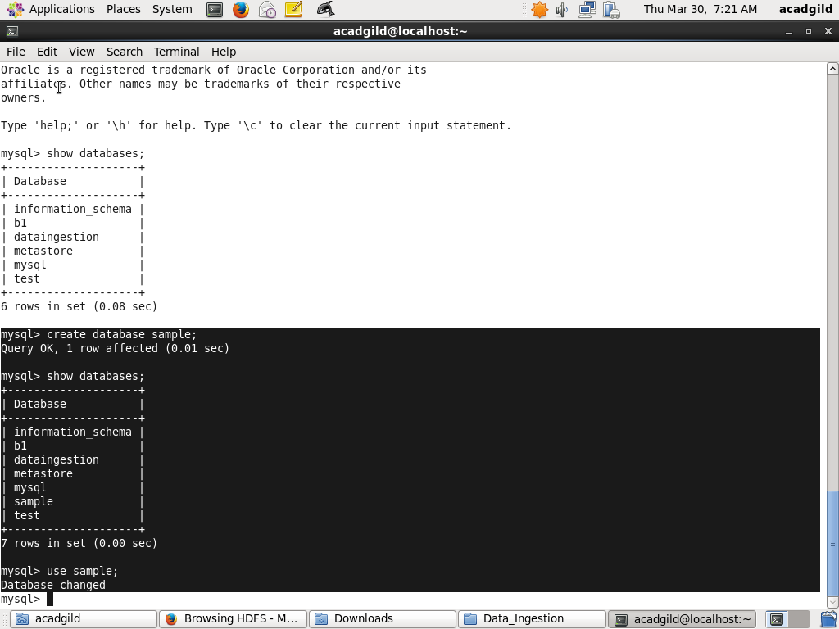

//CREATING THE TABLE EMP

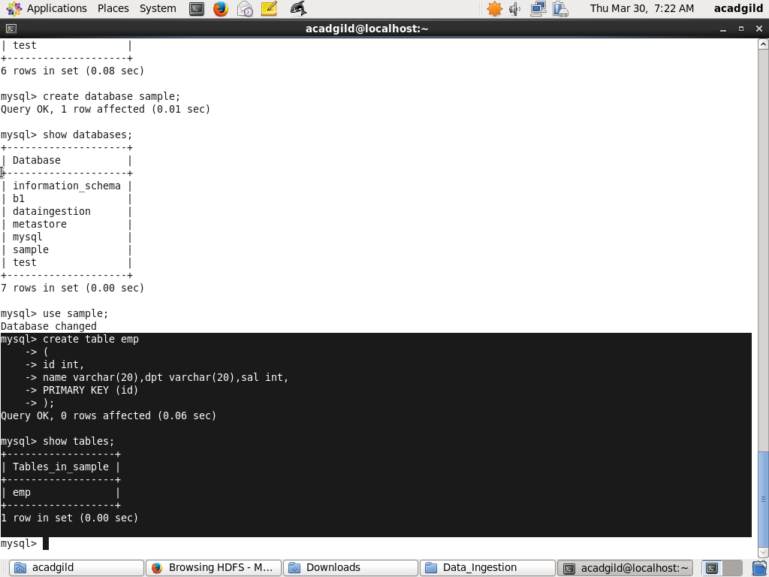

//INSERTING 10 VALUES

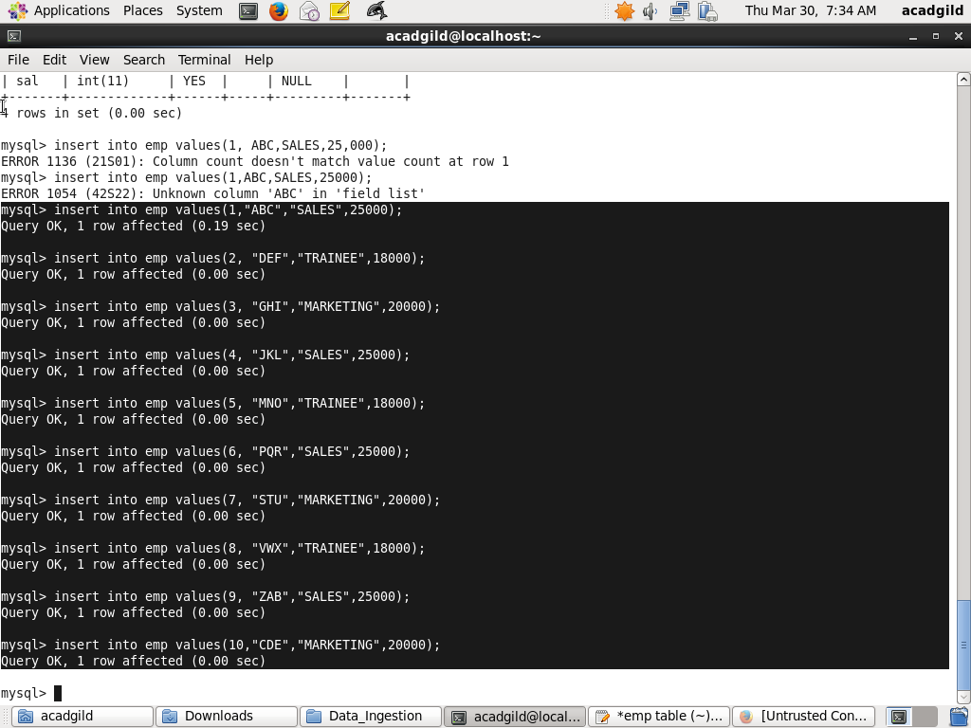

//DATA IN EMP

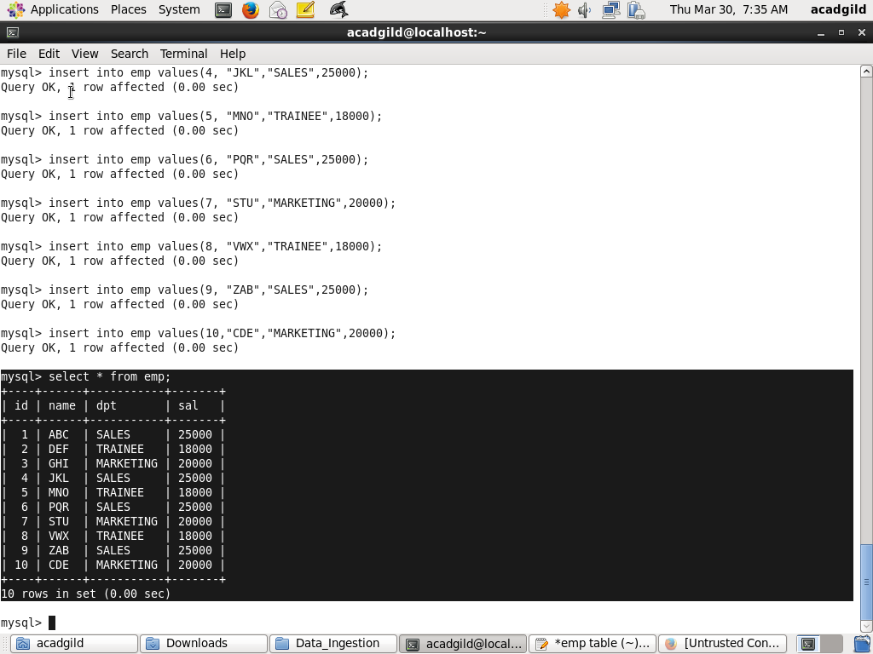

//CREATING TABLE IN HBASE WITH id AS THE CF

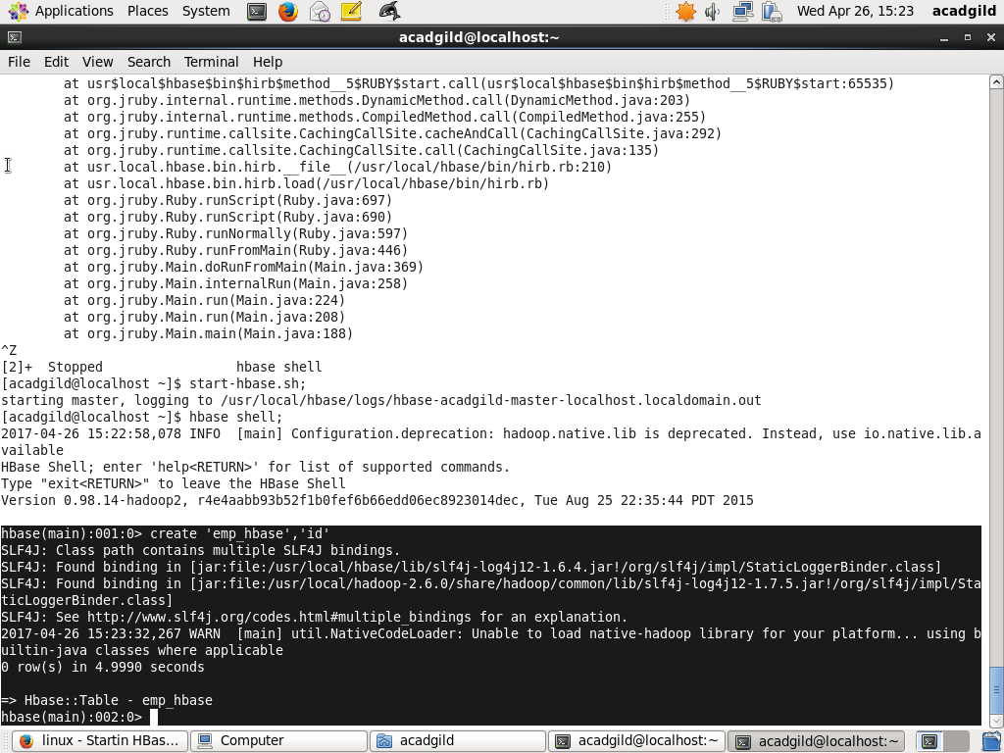

//SQOOP IMPORT into HBASE

